**PROBLEM STATEMENT**

This aims at developing a Machine Learning Model for University Admit Eligibility Predictor. This model helps the students to check their eligibility criteria for entering into colleges. This is based on their competitive exams.

**WORKFLOW:**

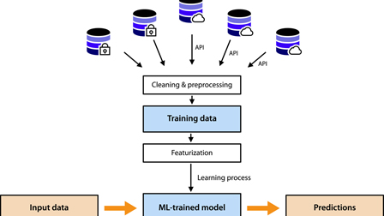

|  |  |
| --- | --- |
| **QUESTION** | **DESCRIPTION** |
| Who does the problem affect? | Students who wish to join colleges based on their scores. |
| Why is it important? | It is easy for students to predict colleges without getting in-person. |
| What are the benefits? | * AI along with ML model * Automatic Prediction * Data Analysis |
| How is it better than the others? | Faster Processing of data with higher accuracy and optimized model. |
| When to use? | Scenario where we want to get admission in college. |